SETTING UP APPLICATION ENVIRONMENT

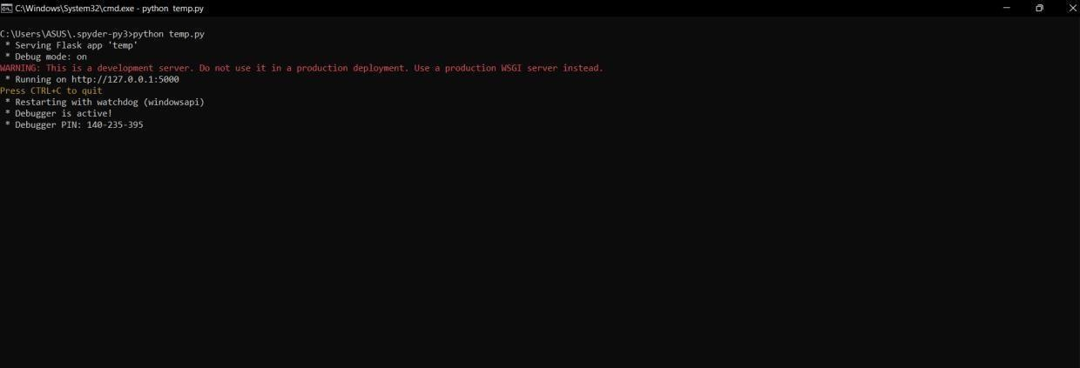

**CREATE FLASK PROJECT:**

|  |  |
| --- | --- |
| **TEAM ID** | PNT2022TMID39592 |
| **TEAM NAME** | Customer Care Registry |

